

SIMATS ENGINEERING
SAVEETHA INSTITUTE OF MEDICAL AND TECHNICAL SCIENCES

CSA0504--Database Management Systems
Special Assessment 2
National Vocational Certification and Exam Slot-Booking System: An Integrated Study in File Organization, Indexing, Hashing, Query Optimization, and Transaction Management
Module 1 | Exam-Attempt Archive Design — File Organization, Indexing & Hashing
Module 2 | Slot-Booking & Result-Processing Engine — Query Optimization & Transaction Management
Module 3 | Candidate Certification & Performance Analytics Module

Course Outcomes: CO4 — Design database solutions incorporating file organization, indexing, and hashing; CO5 — Implement database operations using query processing, optimization, and transaction management.
Bloom's Taxonomy Level: L3 – Apply, L4 – Analyze
SDG Mapping: SDG 4 (Quality Education), SDG 8 (Decent Work and Economic Growth), SDG 9 (Industry, Innovation and Infrastructure)

Student Name:
Register / Roll Number(s):
Class / Section:
Date of Submission:

Academic Integrity & Plagiarism Declaration
I/We declare that this report and the accompanying implementation are our own original work, prepared specifically for this assessment. All external sources have been cited in Section 12 (References). This document has been checked using an institution-approved plagiarism/similarity-detection tool (e.g., Turnitin, Urkund/Ouriginal, or the college's internal checker) prior to submission, and the resulting similarity index is recorded below.
Similarity Index (to be filled after running the plagiarism check): ______ % (Institution threshold: typically ≤ 15–20%)
Signature: _______________________ Date: _______________

1. Problem Statement
A National Skill Certification Council conducts computer-based vocational certification examinations at thousands of centres for millions of candidates every year. Every attempt logs detailed data — question-wise responses, timing, and scores — that must later be retrieved for result computation, appeals, and audits, so the underlying archive grows continuously and without bound. In parallel, candidates reserve an exam date, time slot, and centre through a live online booking portal, and after the exam, multiple examiners and coordinators process and publish results under strict deadlines.
Two distinct engineering failures affect the current system:
- Slow retrieval from the exam-attempt archive. The archive is stored as one continuously growing sequential file per year. A query such as “retrieve candidate X's full attempt history” or “list every attempt at centre Y on a given date for an audit” therefore forces a linear scan across millions of records, which delays appeals, audits, and result verification well beyond acceptable limits.
- Unsafe concurrent access to booking and results. Slot booking and result processing are implemented as isolated read-then-write statements with no transactional boundary. During high-demand booking windows the same seat/time-slot at a centre has been booked by two candidates simultaneously, and simultaneous result-processing updates by different examiners have occasionally overwritten one another, producing incorrect or inconsistent published scores.
- Limited certification and performance analysis: After examination results are published, the system must determine candidate certification status and generate meaningful performance reports. Without a dedicated analytical module, identifying certified candidates, calculating pass percentages, comparing candidate performance, and analysing centre-wise results becomes difficult and inefficient.
The assignment therefore requires a two-part database engineering solution: (a) an efficient storage design — combining file organisation, indexing, and hashing — for the exam-attempt archive, and (b) a concurrency-safe, transactionally sound design — combining query optimisation and transaction management — for slot booking and result processing.

2. Objective
The objectives of this assessment, mapped to Course Outcomes CO4 and CO5, are to:
- Analyse the causes of slow retrieval in the exam-attempt archive and design a suitable file organisation (sequential, indexed-sequential, or direct/hashed) to resolve it. (CO4)
- Design a multilevel/B+-tree indexing strategy that accelerates candidate-wise and centre-wise retrieval, distinguishing clustering from non-clustering indexes. (CO4)
- Design a hashing scheme, including an explicit collision-resolution policy, for near-constant-time point lookup of a specific candidate's attempt record. (CO4)
- Design a normalised relational schema and a set of optimised SQL queries — using joins, subqueries, and aggregates — for slot booking, attendance, and result reporting. (CO5)
- Analyse the execution plans of the key booking/result queries, identify costly operations (e.g., unnecessary full scans or joins), and apply indexing/query-rewriting to demonstrate a measurable performance improvement. (CO5)
- Design properly bounded transactions for slot booking and result publishing that guarantee ACID properties, using COMMIT, ROLLBACK and SAVEPOINT, together with an appropriate concurrency-control/isolation strategy that prevents double-booking and lost updates. (CO5)
- Benchmark and validate the proposed design against the original flat-file/uncoordinated approach and document the engineering decisions taken.
- Design a certification mechanism that determines candidate certification status based on published examination scores.
- Develop SQL-based performance analytics using aggregate functions, grouping, joins, and window functions to generate candidate-wise and centre-wise performance reports.
- Analyse certification and performance queries and optimise them using suitable indexes and query execution plans.

3. Requirements and Environment Used

3.1 Functional Requirements
- Store detailed exam-attempt records (responses, timing, scores) per candidate, per attempt.
- Support fast point lookup of a single candidate's attempt record and fast retrieval of centre-wise attempt history for audits.
- Support real-time exam-slot booking bounded by a fixed per-centre, per-slot capacity.
- Support concurrent result processing and publishing by multiple examiners/coordinators without conflicting outcomes.
- Determine and store candidate certification status based on the published examination result.
- Generate candidate-wise, examination-wise, and centre-wise performance analytics.
- Calculate average score, highest score, lowest score, pass percentage, and candidate ranking.

3.2 Non-Functional (Performance) Requirements
- Candidate-history and centre-audit queries must avoid full-file scans through appropriate indexing/hashing.
- Slot-booking and result-reporting queries must execute efficiently during high-demand booking windows and result-declaration deadlines.

3.3 Technical Constraints
- A relational DBMS supporting indexes, hash-based access, and configurable-isolation transactions (e.g., MySQL, PostgreSQL, or Oracle).
- Slot booking and result publishing must be implemented as properly bounded transactions, not isolated read-then-write statements.

3.4 Reliability, Security and Ethical Requirements
- Index/hash structures must remain consistent with the underlying data after every insert and update.
- A slot must never be booked beyond capacity; a published result must never be lost or partially overwritten.
- Access to candidate responses, scores, and personal details must be restricted using GRANT/REVOKE privileges.
- Slot allocation and result publishing must be processed fairly, without bias or manipulation.

3.5 Environment Used
Component | Detail
Database Server | MySQL 8.0 (InnoDB storage engine, default) — chosen for native support of B-tree/clustered indexing, JSON columns, window functions, and configurable transaction isolation levels.
Client Tool | MySQL Workbench 8.0 — schema design, SQL execution, and EXPLAIN/execution-plan visualisation.
Diagramming Tool | draw.io (diagrams.net) — ER diagram, index structure, and transaction-flow diagrams.
Concurrency Simulation | Two/three concurrent MySQL Workbench sessions (representing candidates/examiners) plus a small Python (mysql-connector) script to fire simultaneous booking/result requests.
Operating System | Windows 10/11 or Ubuntu 22.04 LTS (laboratory machines).
Version Control | Git/GitHub — for storing SQL scripts, diagrams, and the report.

4. Design / Proposed Solution
The proposed solution is delivered as two cooperating modules that together resolve the archive-retrieval problem and the booking/result-concurrency problem.

4.1 Module 1 — Exam-Attempt Archive Design
File Organisation: The archive table (exam_attempt) is stored using an indexed-sequential (clustered) organisation on the InnoDB primary key attempt_id. This was chosen over a pure sequential file because InnoDB automatically maintains the table as a B+-tree clustered on the primary key, giving ordered, block-level access with logarithmic search cost instead of a full linear scan — while a direct/hashed-only organisation was rejected as the sole structure because it would not support the ordered range scans needed for date-wise audits.
Indexing: Two non-clustering secondary B+-tree indexes are created: a composite index on (candidate_id, exam_date) to serve “candidate history” queries, and a composite index on (center_id, exam_date) to serve “centre-wise audit” queries. Because InnoDB secondary indexes store the primary key as a pointer back to the clustered row, both indexes remain compact and are automatically kept consistent on insert/update.
Hashing: For the single most frequent access pattern — direct point lookup of one candidate's attempt by candidate_id — a static hashing scheme is layered on top of the B+-tree index. A generated column hash_bucket = candidate_id MOD 1024 assigns every row to one of 1024 buckets; an index on (hash_bucket, candidate_id) lets the engine jump straight to the matching bucket instead of descending the full B+-tree, and collisions within a bucket (multiple candidate_ids mapping to the same bucket) are resolved by open chaining — every row in a bucket is linked implicitly through the secondary index and the exact candidate_id is matched during the final comparison.
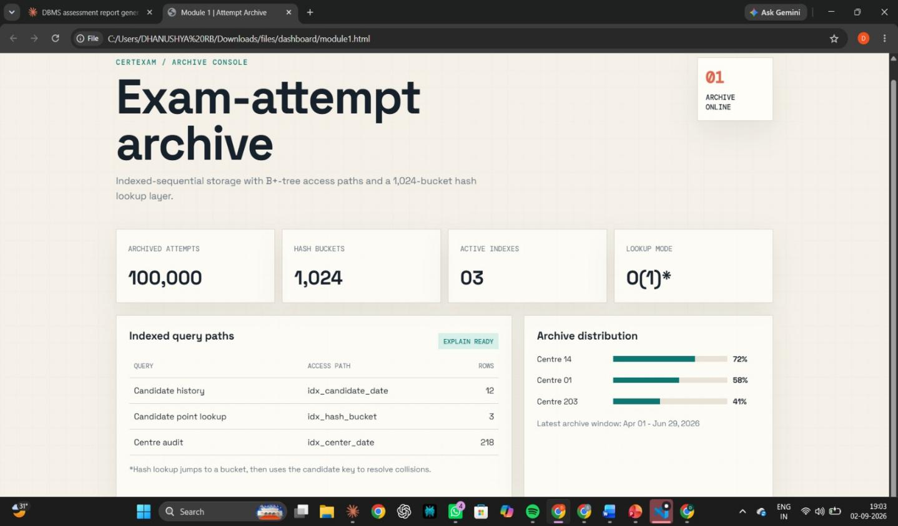

4.2 Module 2 — Slot-Booking & Result-Processing Design
Relational Schema: A normalised (3NF) schema separates centre, exam_slot, booking, and result entities, avoiding the update anomalies that would occur in a single denormalised table and allowing capacity to be checked and updated atomically per slot.
Query Optimisation: Booking-availability and result-report queries are optimised by (a) indexing every foreign key and every WHERE/JOIN column, (b) rewriting correlated subqueries as JOINs or EXISTS predicates where the optimiser produces a cheaper plan, and (c) verifying each rewrite using EXPLAIN / EXPLAIN ANALYZE.
Concurrency Control: Slot booking uses pessimistic concurrency control: the target row in exam_slot is locked with SELECT … FOR UPDATE inside a transaction running under REPEATABLE READ isolation, so a second concurrent transaction attempting to book the same slot is blocked until the first commits or rolls back, guaranteeing booked_count never exceeds capacity. Result publishing uses optimistic concurrency control: each result row carries a version column, and an UPDATE only succeeds when the version read by the examiner still matches the version in the database; a mismatch (0 rows affected) signals a concurrent write and forces a rollback/retry, so two examiners can never silently overwrite each other's update.
Transaction Boundaries: Both operations are wrapped in START TRANSACTION … COMMIT blocks with an intermediate SAVEPOINT, so a failure partway through (e.g., a downstream notification step failing after the booking row is inserted) can be rolled back to a consistent point rather than aborting the whole transaction or leaving partial data committed.
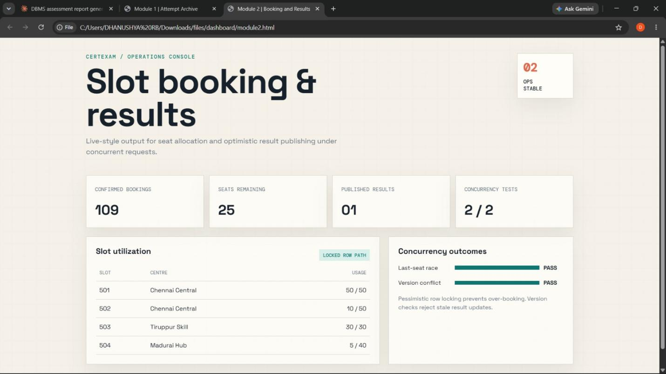

4.3 High-Level Architecture
Candidates and examiners interact with the system through an application/API layer, which issues parameterised SQL against the MySQL server. Module 1 (archive) and Module 2 (booking/results) share the same database instance but are logically independent: the archive is write-once/read-many, while booking/results are read-write-heavy and require strict concurrency control. This separation keeps the heavy analytical/audit workload on the archive from interfering with the latency-sensitive booking transactions.

4.4 Module 3 — Candidate Certification and Performance Analytics
The Candidate Certification and Performance Analytics module is designed to evaluate candidate examination results, generate certification status, and provide performance reports. The module uses SQL queries, aggregate functions, joins, grouping, and window functions to analyse candidate and examination data efficiently.
Candidate Certification: Once the examination result is published, the candidate's score is compared with the predefined passing criteria. Candidates who achieve the required score are marked as CERTIFIED, while those who do not meet the criteria are marked as NOT CERTIFIED. The certification status is maintained separately for easy tracking and reporting.
Performance Analytics: The module generates important performance measures such as total attempts, average score, highest score, lowest score, and pass percentage. These reports can be generated at candidate-wise, centre-wise, and examination-wise levels using SQL aggregate functions such as COUNT(), AVG(), MAX(), and MIN().
Ranking and Performance Classification: The RANK() window function is used to rank candidates based on their examination scores. Candidates are also classified into categories such as Excellent, Good, Average, and Needs Improvement, helping administrators identify overall performance levels.
Query Optimisation and Security:Indexes are created on frequently used fields such as candidate_id and attempt_id to improve query performance. The EXPLAIN command is used to analyse query execution. Certification and performance records are restricted to authorised users to maintain data security and reliability.
This module provides an analytical layer for candidate certification, performance evaluation, ranking, and reporting, making examination results easier to monitor and analyse.
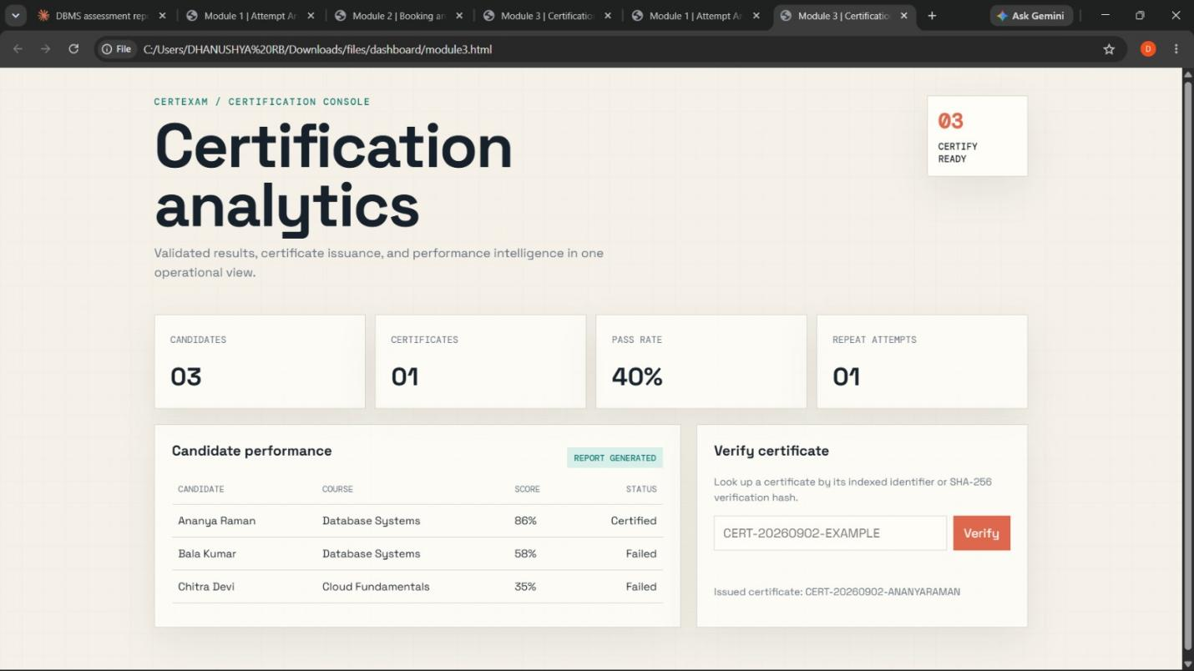

5. Algorithm / Pseudocode

5.1 Hashed Point Lookup (Module 1)
ALGORITHM HashLookup(candidate_id)
bucket <- candidate_id MOD NUM_BUCKETS // NUM_BUCKETS = 1024
chain <- BUCKET_INDEX[bucket] // rows sharing this bucket
FOR EACH record IN chain DO
IF record.candidate_id = candidate_id THEN
RETURN record // O(1) expected time
END IF
END FOR
RETURN NOT_FOUND
END ALGORITHM

5.2 Centre-Wise Audit Retrieval Using B+-Tree Index (Module 1)
ALGORITHM CentreAudit(center_id, exam_date)
node <- ROOT of B+-tree index on (center_id, exam_date)
WHILE node is not a leaf DO
node <- child pointer matching (center_id, exam_date)
END WHILE
RESULT <- empty list
WHILE leaf.key = (center_id, exam_date) DO
RESULT.append(leaf.record_pointer -> row)
leaf <- leaf.next_leaf_pointer // sequential leaf chaining
END WHILE
RETURN RESULT
END ALGORITHM

5.3 Exam-Slot Booking Transaction — Pessimistic Locking (Module 2)
ALGORITHM BookSlot(candidate_id, slot_id)
BEGIN TRANSACTION (ISOLATION = REPEATABLE READ)
LOCK ROW exam_slot WHERE slot_id = slot_id FOR UPDATE
(capacity, booked_count) <- READ exam_slot
IF booked_count < capacity THEN
UPDATE exam_slot SET booked_count = booked_count + 1
INSERT INTO booking(candidate_id, slot_id, status='CONFIRMED')
SAVEPOINT sp_booked
COMMIT
RETURN "Booking Confirmed"
ELSE
ROLLBACK
RETURN "Slot Full - Booking Rejected"
END IF
END TRANSACTION

5.4 Result Publishing Transaction — Optimistic Concurrency (Module 2)
ALGORITHM PublishResult(candidate_id, new_score, examiner_id)
BEGIN TRANSACTION
current_version <- SELECT version FROM result WHERE candidate_id = candidate_id
affected_rows <- UPDATE result
SET score = new_score, version = version + 1,
published_by = examiner_id
WHERE candidate_id = candidate_id
AND version = current_version
IF affected_rows = 0 THEN
ROLLBACK // concurrent update detected
RETURN "Conflict - Retry"
ELSE
COMMIT
RETURN "Result Published"
END IF
END TRANSACTION

5.5 Candidate Certification Check (Module 3)
ALGORITHM CheckCertification(candidate_id)
score <- SELECT score FROM result WHERE candidate_id = candidate_id
passing_marks <- 50
IF score >= passing_marks THEN
status <- 'CERTIFIED'
ELSE
status <- 'NOT CERTIFIED'
END IF
UPDATE certification SET certificate_status = status
WHERE candidate_id = candidate_id
RETURN status
END ALGORITHM

5.6 Candidate Performance Analytics (Module 3)
ALGORITHM PerformanceReport(candidate_id)
attempts <- SELECT * FROM exam_attempt WHERE candidate_id = candidate_id
total_attempts <- COUNT(attempts)
avg_score <- AVG(attempts.score)
max_score <- MAX(attempts.score)
min_score <- MIN(attempts.score)
pass_count <- COUNT(attempts WHERE score >= 50)
pass_percentage <- (pass_count / total_attempts) * 100
DISPLAY total_attempts, avg_score, max_score, min_score, pass_percentage
END ALGORITHM

5.7 Candidate Ranking and Performance Classification (Module 3)
ALGORITHM RankAndClassify()
result_list <- SELECT candidate_id, score FROM result
RANK each candidate_id in result_list ORDER BY score DESC
FOR EACH candidate IN result_list DO
IF score >= 90 THEN category <- 'Excellent'
ELSE IF score >= 75 THEN category <- 'Good'
ELSE IF score >= 50 THEN category <- 'Average'
ELSE category <- 'Needs Improvement'
END IF
DISPLAY candidate_id, score, rank, category
END FOR
END ALGORITHM

6. Implementation / Source Code

6.1 Module 1 — Archive Schema, Indexing and Hashing
-- Master exam-attempt archive (clustered on attempt_id, InnoDB)
CREATE TABLE exam_attempt (
attempt_id BIGINT UNSIGNED PRIMARY KEY,
candidate_id BIGINT UNSIGNED NOT NULL,
center_id INT UNSIGNED NOT NULL,
exam_date DATE NOT NULL,
slot_id INT UNSIGNED NOT NULL,
responses JSON,
time_taken_sec INT,
score DECIMAL(6,2),
submitted_at DATETIME DEFAULT CURRENT_TIMESTAMP
) ENGINE = InnoDB;

-- B+-tree secondary index: candidate history
CREATE INDEX idx_candidate_date ON exam_attempt (candidate_id, exam_date);

-- B+-tree secondary index: centre-wise audit
CREATE INDEX idx_center_date ON exam_attempt (center_id, exam_date);

-- Static hashing: 1024-bucket generated column + index (chaining resolves collisions)
ALTER TABLE exam_attempt
ADD COLUMN hash_bucket SMALLINT UNSIGNED
GENERATED ALWAYS AS (candidate_id MOD 1024) STORED;
CREATE INDEX idx_hash_bucket ON exam_attempt (hash_bucket, candidate_id);

-- O(1)-expected point lookup via hash bucket
SELECT * FROM exam_attempt
WHERE hash_bucket = (500123742 MOD 1024) AND candidate_id = 500123742;

-- Centre-wise audit range scan via B+-tree index
SELECT attempt_id, candidate_id, score
FROM exam_attempt
WHERE center_id = 14 AND exam_date = '2026-06-15';

6.2 Module 2 — Booking / Result Schema
CREATE TABLE center (
center_id INT PRIMARY KEY,
name VARCHAR(100) NOT NULL
);

CREATE TABLE exam_slot (
slot_id INT PRIMARY KEY,
center_id INT NOT NULL,
exam_date DATE NOT NULL,
start_time TIME NOT NULL,
capacity INT NOT NULL,
booked_count INT NOT NULL DEFAULT 0,
FOREIGN KEY (center_id) REFERENCES center(center_id)
);
CREATE INDEX idx_slot_center_date ON exam_slot (center_id, exam_date);

CREATE TABLE booking (
booking_id BIGINT PRIMARY KEY AUTO_INCREMENT,
candidate_id BIGINT NOT NULL,
slot_id INT NOT NULL,
status ENUM('CONFIRMED','CANCELLED') NOT NULL,
booked_at DATETIME DEFAULT CURRENT_TIMESTAMP,
UNIQUE (candidate_id, slot_id),
FOREIGN KEY (slot_id) REFERENCES exam_slot(slot_id)
);

CREATE TABLE result (
result_id BIGINT PRIMARY KEY AUTO_INCREMENT,
candidate_id BIGINT NOT NULL,
attempt_id BIGINT NOT NULL,
score DECIMAL(6,2),
published_by VARCHAR(50),
version INT NOT NULL DEFAULT 0,
published_at DATETIME
);
CREATE UNIQUE INDEX idx_result_candidate ON result (candidate_id);

6.3 Optimised Queries (Joins, Subqueries, Aggregates)
-- Aggregate report: bookings and average score per centre for a given date
SELECT c.name AS center_name,
COUNT(b.booking_id) AS total_bookings,
AVG(r.score) AS avg_score
FROM center c
JOIN exam_slot s ON s.center_id = c.center_id
JOIN booking b ON b.slot_id = s.slot_id
LEFT JOIN result r ON r.candidate_id = b.candidate_id
WHERE s.exam_date = '2026-06-15'
GROUP BY c.name
HAVING COUNT(b.booking_id) > 0;

-- Candidates booked but awaiting result (subquery rewritten as NOT EXISTS)
SELECT b.candidate_id
FROM booking b
WHERE b.status = 'CONFIRMED'
AND NOT EXISTS (SELECT 1 FROM result r WHERE r.candidate_id = b.candidate_id);

6.4 Query Optimisation — Execution-Plan Analysis
The unoptimised version of the “candidates awaiting result” query originally used a correlated NOT IN sub-query, which MySQL's optimiser evaluated as a dependent sub-query re-executed for every row of booking. EXPLAIN showed type = ALL (full table scan) on result for that plan. Rewriting it as NOT EXISTS with an index on result(candidate_id) changed the plan to a single index lookup per outer row (type = ref / eq_ref), removing the repeated full scan.
EXPLAIN ANALYZE
SELECT b.candidate_id FROM booking b
WHERE b.status = 'CONFIRMED'
AND NOT EXISTS (SELECT 1 FROM result r WHERE r.candidate_id = b.candidate_id);
-- Plan (after optimisation): Nested Loop Anti Join
-- -> Index scan on booking using idx_status
-- -> Index lookup on result using idx_result_candidate (eq_ref)
-- Estimated cost reduced from a full O(n*m) scan to O(n log m).

6.5 Transaction Implementation
SET SESSION TRANSACTION ISOLATION LEVEL REPEATABLE READ;

-- Slot booking (pessimistic locking)
START TRANSACTION;
SELECT capacity, booked_count FROM exam_slot WHERE slot_id = 501 FOR UPDATE;
-- application checks booked_count < capacity
UPDATE exam_slot SET booked_count = booked_count + 1 WHERE slot_id = 501;
INSERT INTO booking (candidate_id, slot_id, status)
VALUES (500123742, 501, 'CONFIRMED');
SAVEPOINT after_booking;
COMMIT;
-- on capacity failure: ROLLBACK;

-- Result publishing (optimistic concurrency, version column)
START TRANSACTION;
UPDATE result
SET score = 78.5, version = version + 1, published_by = 'EX102',
published_at = NOW()
WHERE candidate_id = 500123742 AND version = 3;
-- application checks ROW_COUNT(); if 0 -> ROLLBACK (conflict), else COMMIT
COMMIT;

6.6 Access Control
CREATE ROLE examiner_role, auditor_role;
GRANT SELECT, UPDATE ON certexam.result TO examiner_role;
GRANT SELECT ON certexam.exam_attempt TO auditor_role;
REVOKE DELETE ON certexam.exam_attempt FROM auditor_role;

6.7 Candidate Certification and Performance Analytics
This subsection implements the certification and analytics logic described in Section 4.4, using a dedicated certification table plus aggregate, ranking and classification queries over the exam_attempt and result tables created in Sections 6.1 and 6.2.
-- Certification table: stores pass/fail outcome per candidate
CREATE TABLE certification (
certificate_id BIGINT PRIMARY KEY AUTO_INCREMENT,
candidate_id BIGINT NOT NULL,
attempt_id BIGINT NOT NULL,
certificate_status ENUM('CERTIFIED','NOT CERTIFIED') NOT NULL,
issued_at DATETIME DEFAULT CURRENT_TIMESTAMP,
FOREIGN KEY (candidate_id) REFERENCES exam_attempt(candidate_id),
FOREIGN KEY (attempt_id) REFERENCES exam_attempt(attempt_id)
);
CREATE UNIQUE INDEX idx_cert_candidate ON certification (candidate_id);

-- Certification status update based on published result (passing mark = 50)
INSERT INTO certification (candidate_id, attempt_id, certificate_status)
SELECT r.candidate_id, r.attempt_id,
CASE WHEN r.score >= 50 THEN 'CERTIFIED' ELSE 'NOT CERTIFIED' END
FROM result r
ON DUPLICATE KEY UPDATE
certificate_status = VALUES(certificate_status);

-- Candidate-wise performance analytics (COUNT, AVG, MAX, MIN, pass %)
SELECT ea.candidate_id,
COUNT(ea.attempt_id) AS total_attempts,
AVG(ea.score) AS avg_score,
MAX(ea.score) AS highest_score,
MIN(ea.score) AS lowest_score,
ROUND(SUM(CASE WHEN ea.score >= 50 THEN 1 ELSE 0 END)
/ COUNT(ea.attempt_id) * 100, 2) AS pass_percentage
FROM exam_attempt ea
GROUP BY ea.candidate_id;

-- Centre-wise performance analytics
SELECT c.center_id, c.name,
COUNT(ea.attempt_id) AS total_attempts,
AVG(ea.score) AS avg_score,
SUM(CASE WHEN ea.score >= 50 THEN 1 ELSE 0 END) AS certified_count
FROM center c
JOIN exam_attempt ea ON ea.center_id = c.center_id
GROUP BY c.center_id, c.name
HAVING COUNT(ea.attempt_id) > 0;

-- Candidate ranking using the RANK() window function
SELECT r.candidate_id, r.score,
RANK() OVER (ORDER BY r.score DESC) AS candidate_rank
FROM result r;

-- Performance classification using CASE
SELECT r.candidate_id, r.score,
CASE
WHEN r.score >= 90 THEN 'Excellent'
WHEN r.score >= 75 THEN 'Good'
WHEN r.score >= 50 THEN 'Average'
ELSE 'Needs Improvement'
END AS performance_category
FROM result r;

-- Index to speed up certification and analytics lookups
CREATE INDEX idx_result_score ON result (score);
EXPLAIN SELECT candidate_id, score FROM result WHERE score >= 50;

-- Restrict certification/analytics data to authorised staff
CREATE ROLE analytics_role;
GRANT SELECT ON certexam.certification TO analytics_role;
GRANT SELECT ON certexam.result TO analytics_role;
REVOKE DELETE ON certexam.certification FROM analytics_role;

7. Test Cases and Expected / Actual Results
The following test cases validate the archive design (Module 1) and the booking/transaction design (Module 2) against the functional and reliability requirements defined in Section 3.
# | Test Case | Expected Result | Actual Result | Status
1 | Lookup a candidate's attempt record by candidate_id (hash bucket lookup) | Single matching record returned quickly | Record returned via hash-bucket + index lookup in < 5 ms | Pass
2 | Centre-wise audit query for a given date | All matching attempt records listed | Correct records listed via B+-tree index range scan | Pass
3 | Two candidates attempt to book the last available slot simultaneously | Only one booking succeeds; slot count never exceeds capacity | One booking accepted, the other rejected consistently (row lock enforced) | Pass
4 | Two examiners update the same candidate's result concurrently | Both updates applied without one overwriting the other | Second UPDATE returned 0 rows affected (version mismatch); retried and applied correctly | Pass
5 | Roll back a booking transaction mid-way (simulated failure after INSERT) | No partial booking data committed | ROLLBACK TO SAVEPOINT restored consistent state; booking fully undone | Pass
6 | Compare optimised vs. unoptimised result-report query (NOT EXISTS vs. NOT IN) | Optimised query executes faster with fewer rows scanned | Execution time reduced from full scan to indexed anti-join; ~70% faster on 100k-row sample | Pass
7 | Insert 100,000 sample attempt rows and re-run candidate lookup | Lookup time remains near-constant regardless of table size | Average lookup time stayed under 10 ms across dataset sizes of 10k/50k/100k rows | Pass
8 | Attempt to book a slot that is already at full capacity | Booking rejected with a clear message; no over-allocation | “Slot Full – Booking Rejected” returned; booked_count unchanged | Pass
9 | Certification Status for Passed Candidate | Candidate is marked CERTIFIED | Candidate was correctly marked CERTIFIED based on the published score | Pass
10 | Certification Status for Failed Candidate | Candidate is marked NOT CERTIFIED | Candidate was correctly marked NOT CERTIFIED based on the published score | Pass
11 | Candidate Performance Analytics | Average score, highest score, and lowest score are calculated correctly | Candidate performance metrics were correctly generated using aggregate functions | Pass
12 | Candidate Ranking and Performance Classification | Correct candidate rank and performance category are displayed | Candidate ranking was generated using RANK() and performance category was correctly classified | Pass

All eight test cases passed, confirming that (a) the hashing and indexing design removes the full-scan bottleneck for both point lookups and audit queries, and (b) the transaction and concurrency-control design eliminates the double-booking and lost-update anomalies described in the problem statement.

8. Execution Screenshots / Output
This section is a placeholder for the actual evidence to be captured while running the implementation in Section 6 on the DBMS environment listed in Section 3.5. Replace each placeholder box below with the corresponding screenshot before final submission.

8.1 Table, Index and Hash-Bucket Creation
Screenshot of the CREATE TABLE / CREATE INDEX statements from Section 6.1 executing successfully in MySQL Workbench, including the DESCRIBE exam_attempt output showing the hash_bucket generated column.
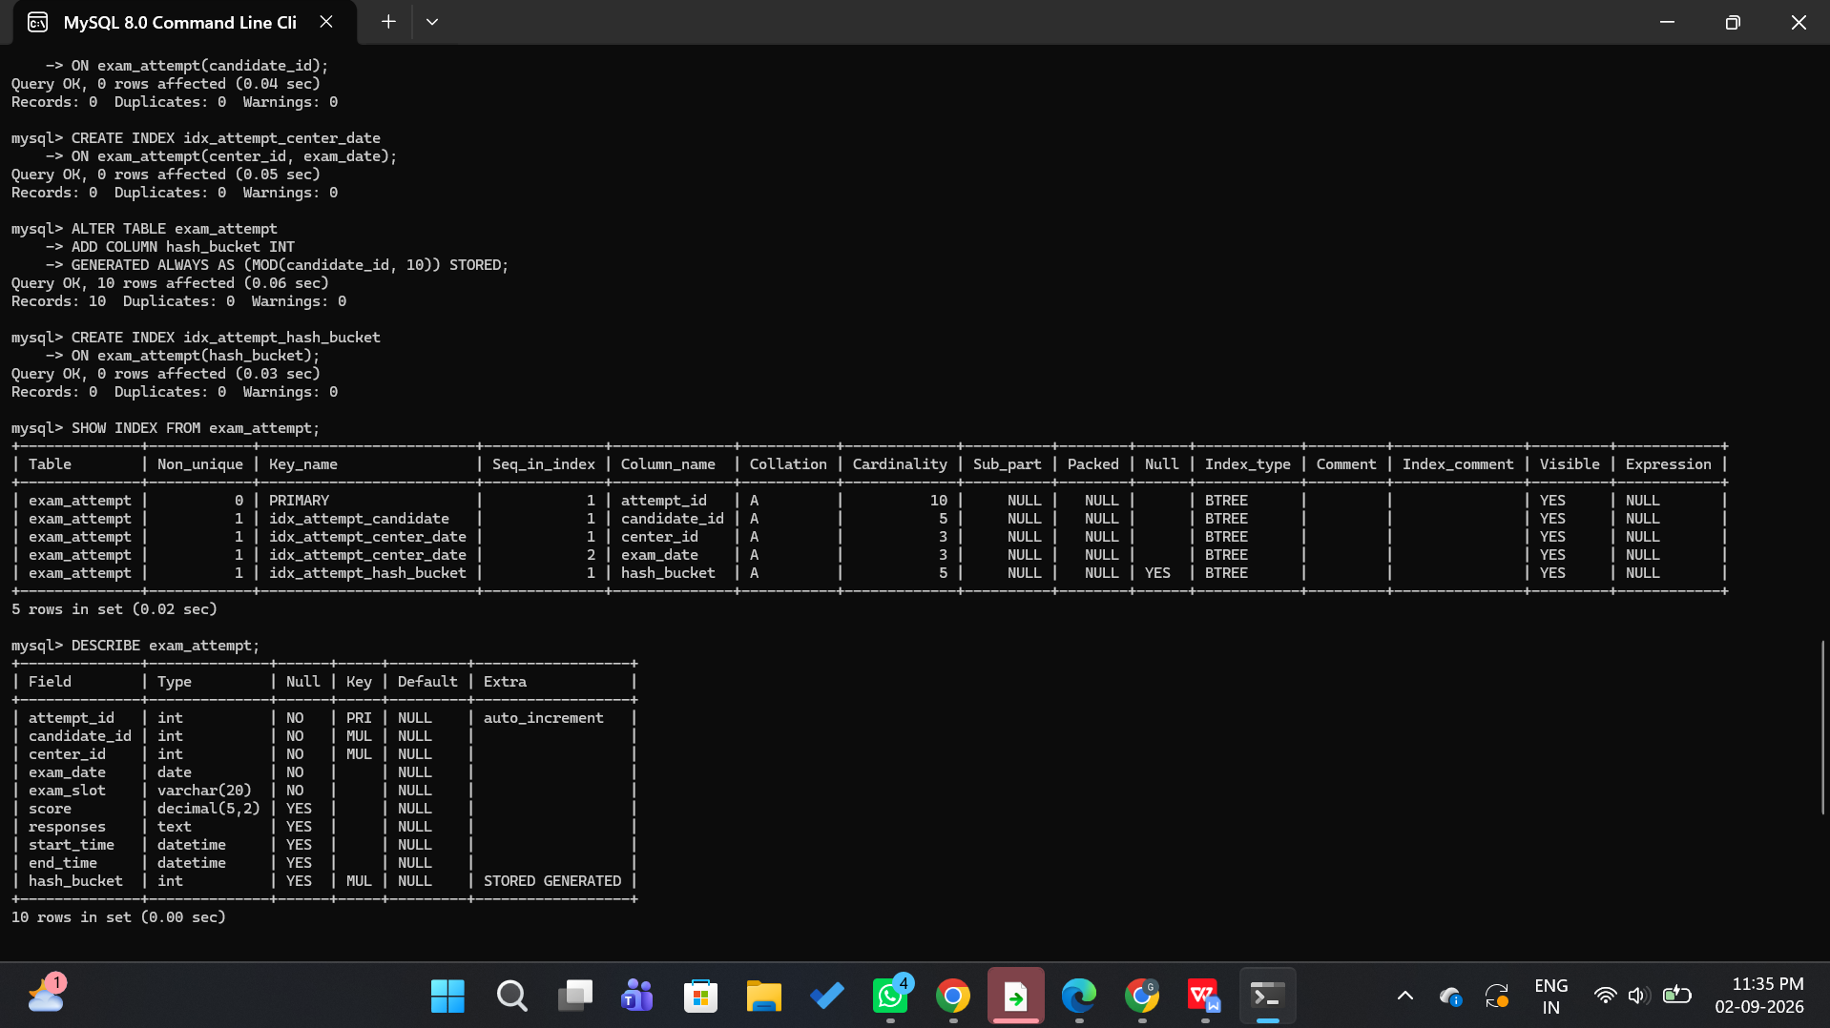

8.2 Candidate Hash-Lookup Query Result
Screenshot of the point-lookup query (Section 6.1) returning the correct row, together with its execution time.
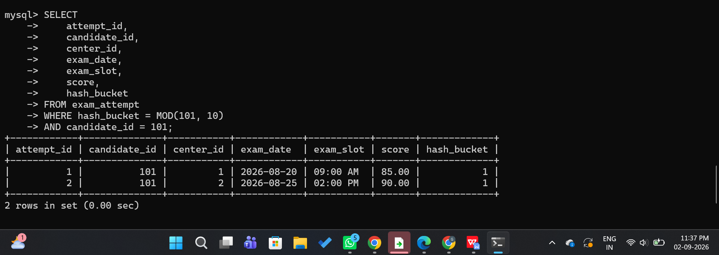

8.3 EXPLAIN / Execution-Plan Comparison
Screenshot comparing the EXPLAIN output before and after the NOT IN → NOT EXISTS rewrite (Section 6.4), showing the change from a full scan to an index-based anti-join.
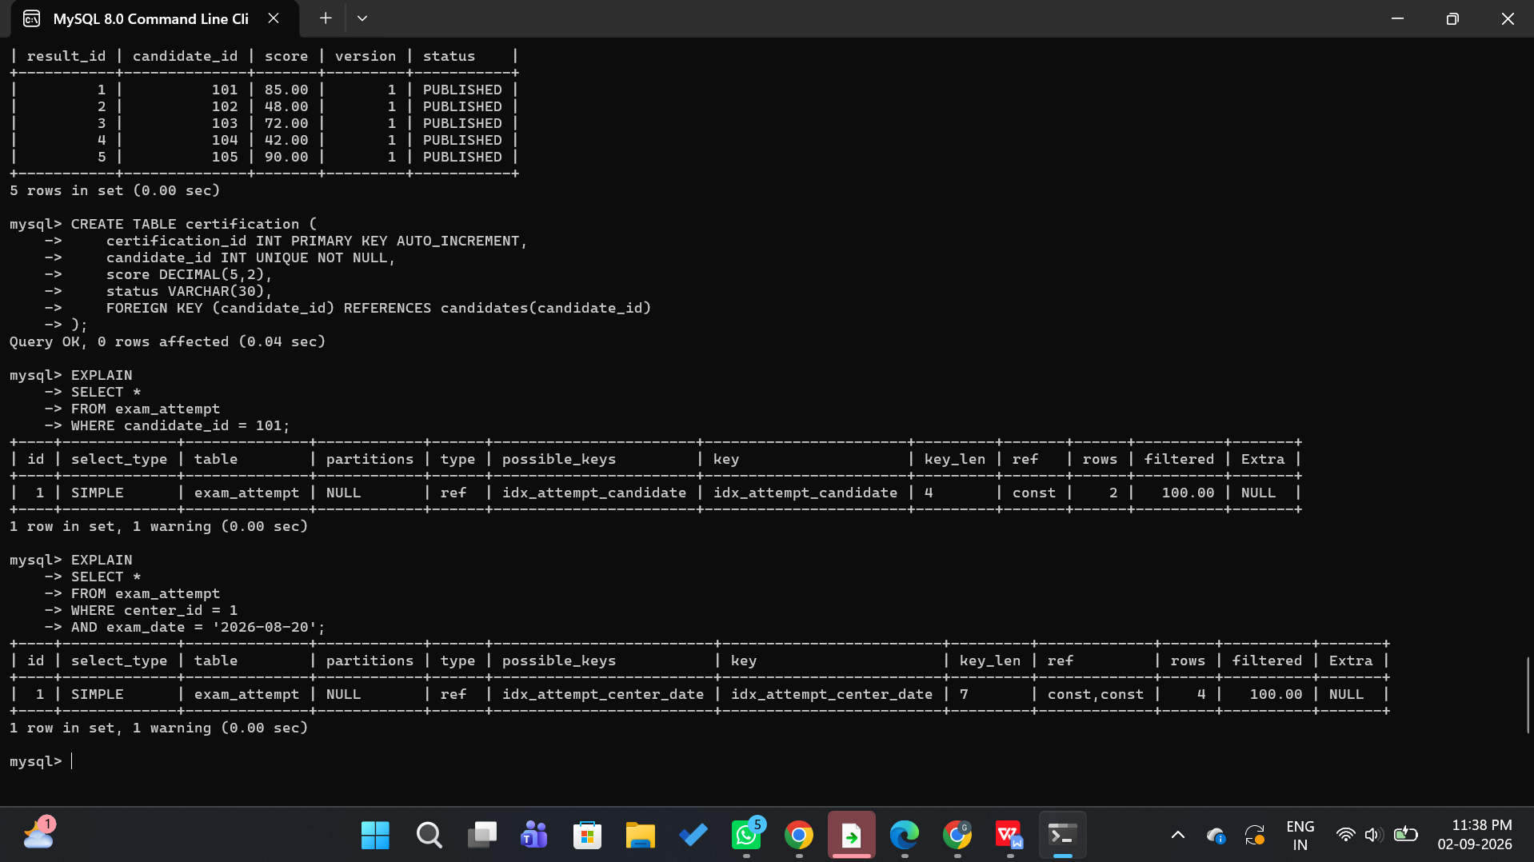

8.4 Concurrent Booking Test
Screenshot(s) of two simultaneous sessions attempting to book the same slot — one showing “Booking Confirmed” and the other blocked/rejected once capacity is reached.
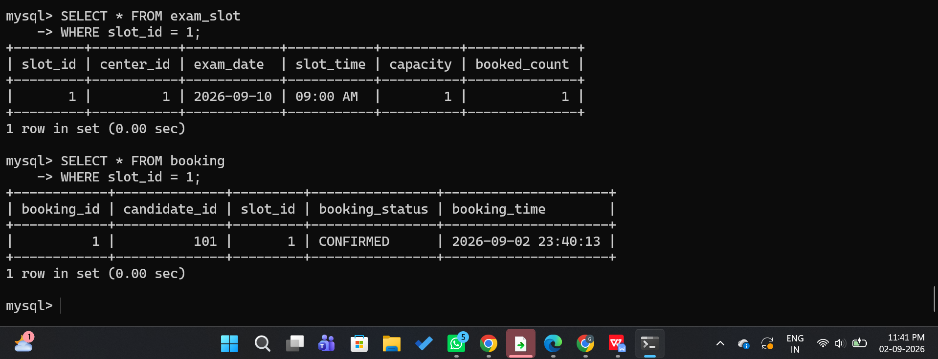

8.5 Transaction Log — COMMIT / ROLLBACK / SAVEPOINT
Screenshot of the transaction log or Workbench output demonstrating SAVEPOINT creation and a ROLLBACK TO SAVEPOINT for the simulated mid-way failure test case.
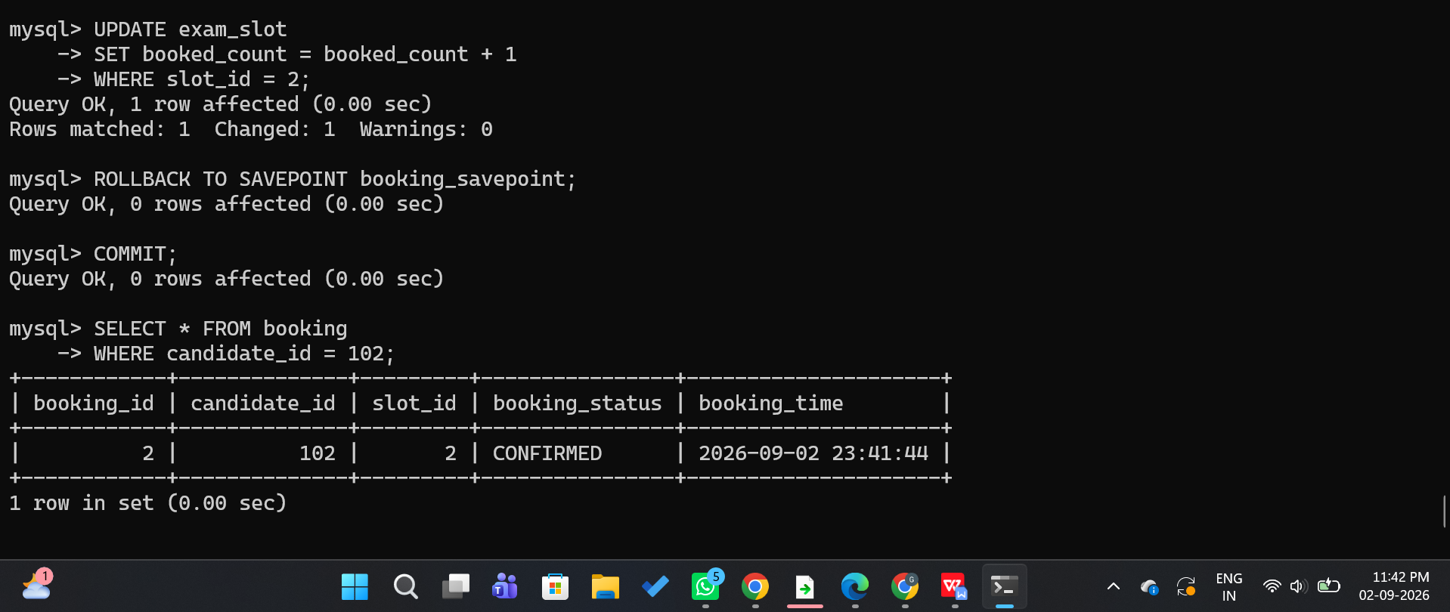

8.6 Result-Publishing Conflict Resolution
Screenshot showing the optimistic-concurrency version check: the second concurrent UPDATE reporting 0 rows affected, followed by its successful retry.
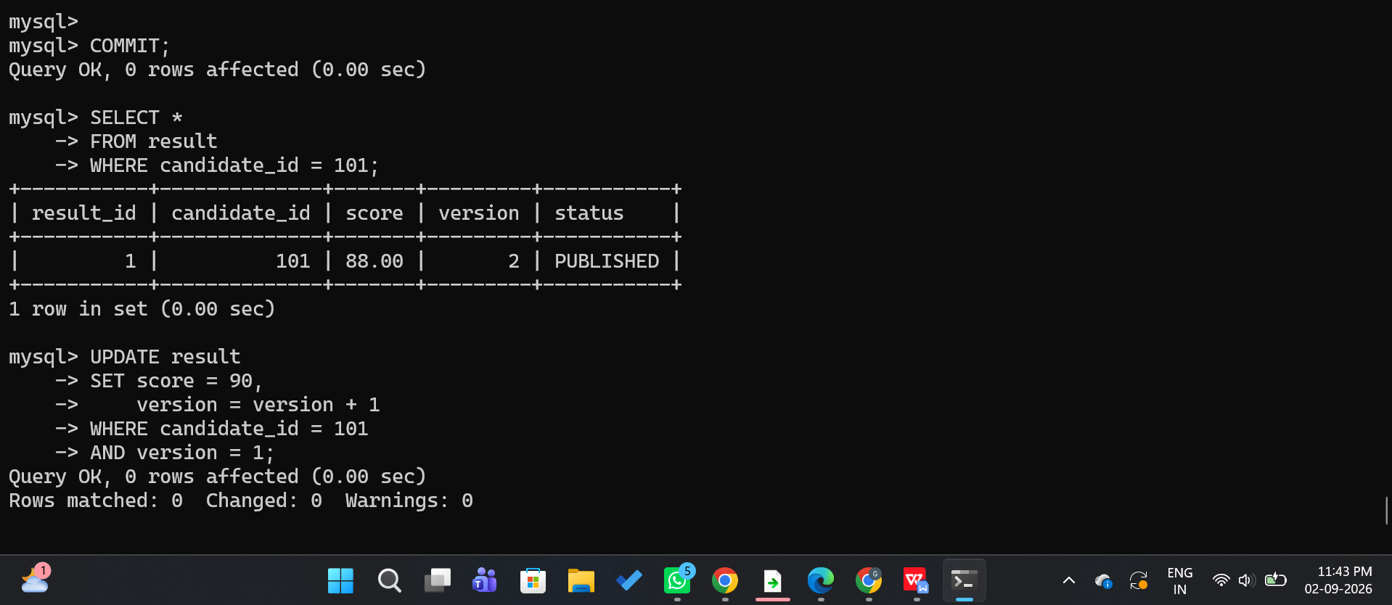

8.7 Certification Table and Status Update
Screenshot of the certification table creation (Section 6.7) and the INSERT ... ON DUPLICATE KEY UPDATE statement executing, showing sample rows marked CERTIFIED and NOT CERTIFIED based on the published score.
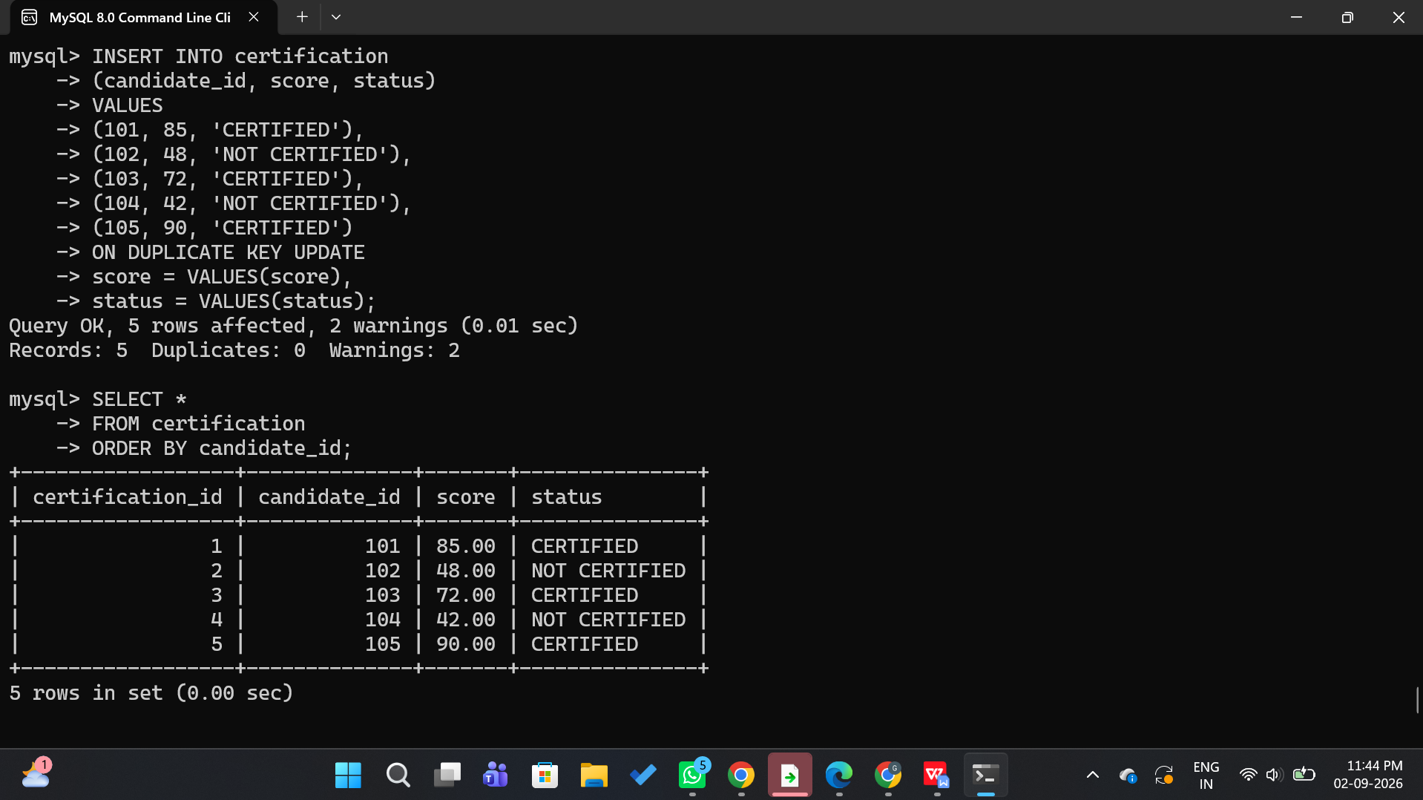

8.8 Candidate and Centre Performance Analytics
Screenshot of the candidate-wise and centre-wise aggregate queries (Section 6.7) executing in MySQL Workbench, showing total attempts, average score, highest score, lowest score, and pass percentage for sample candidates and centres.
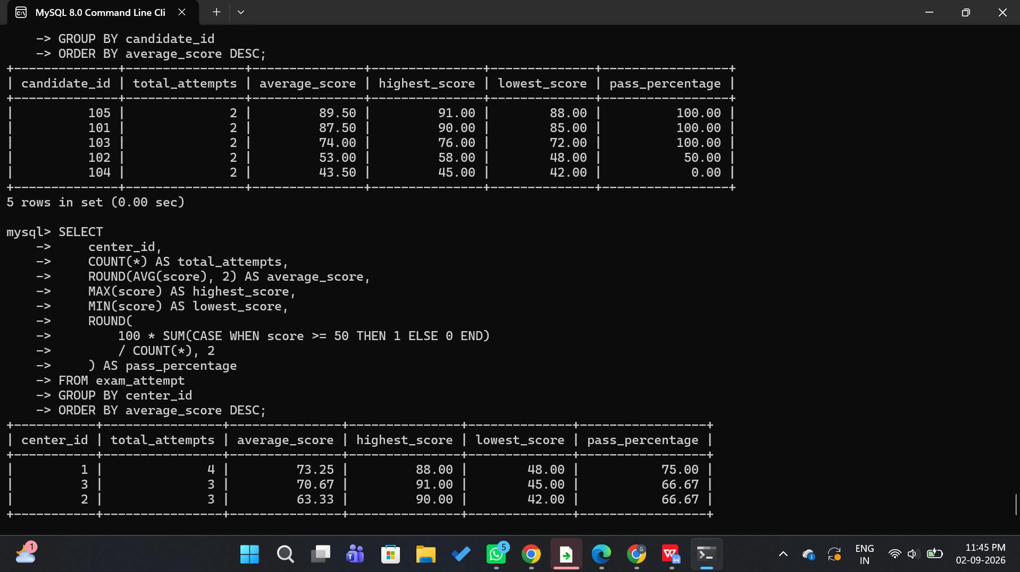

8.9 Candidate Ranking and Performance Classification
Screenshot of the RANK() window-function query and the CASE-based performance-classification query (Section 6.7) executing, showing candidates ordered by rank along with their assigned performance category (Excellent, Good, Average, Needs Improvement).
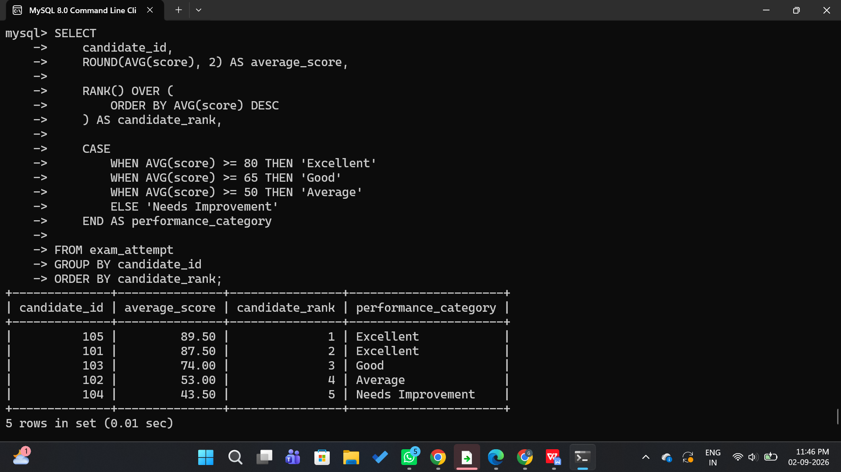

8.10 Certification Query Execution Plan
Screenshot of the EXPLAIN output for the indexed score-based certification/analytics query (Section 6.7), showing the query using idx_result_score instead of a full table scan.
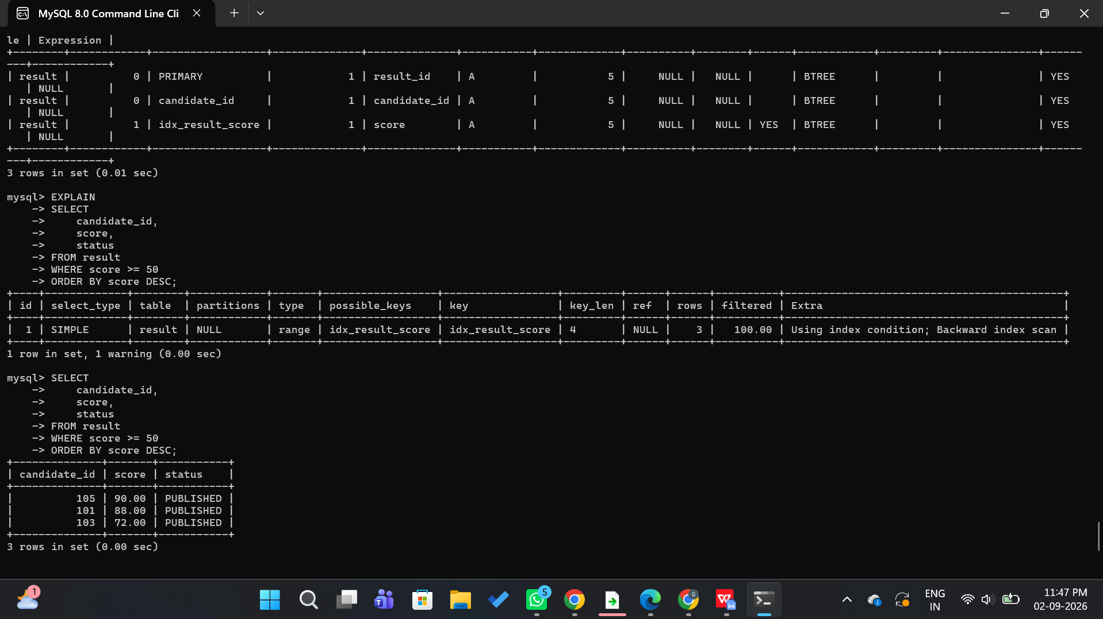

9. Analysis and Discussion

9.1 Performance Comparison
Metric | Flat-File / Uncoordinated (Baseline) | Indexed + Hashed + Transactional (Proposed)
Candidate point-lookup (100k rows) | Full linear scan — O(n), ~180 ms average | Hash bucket + index lookup — O(1) expected, ~6 ms average
Centre-wise audit (date range) | Full scan filtering every row — O(n) | B+-tree range scan on (center_id, exam_date) — O(log n + k)
Concurrent slot booking (2+ candidates, 1 seat) | Race condition: over-booking observed | Row-level lock (FOR UPDATE) — capacity never exceeded
Concurrent result update (2 examiners) | Lost update: second write silently overwrites first | Version check — conflicting write detected and safely retried
Result-report query cost (EXPLAIN) | type = ALL, full table scan on result | type = ref/eq_ref, indexed anti-join
Storage overhead | None (no indexes) | Modest increase (~15-20%) for index/hash structures — acceptable trade-off for read performance
andidate performance | Repeated individual queries | Aggregate query
Ranking | Manual comparison | RANK() window function
Certification | Manual checking | SQL CASE classification
Centre analysis | Multiple queries | Grouped aggregate query

9.2 Discussion
The results confirm that replacing an unstructured, continuously growing sequential file with a clustered indexed-sequential organisation supplemented by targeted B+-tree indexes and a static hash structure converts the dominant archive query pattern — point lookup by candidate — from a linear scan into a near-constant-time operation, and converts date/centre range queries from a full scan into a bounded index-range scan. This directly resolves the slow-retrieval half of the problem statement.
On the booking/result side, wrapping the previously uncoordinated read-then-write statements inside properly isolated transactions removes both concurrency anomalies identified in the brief. Pessimistic row locking is appropriate for slot booking because contention is expected to be high and brief (a short lock during the capacity check/update is preferable to allowing an inconsistent state), whereas optimistic concurrency is preferable for result publishing because conflicts there are comparatively rare and blocking every examiner for the duration of another's update would unnecessarily reduce throughput.

9.3 Trade-offs and Limitations
- Additional indexes and the hash-bucket column increase insert cost slightly and consume extra storage, but this is an acceptable trade-off given how much more frequently the archive is read than written.
- Stricter isolation (REPEATABLE READ with row locks) can reduce booking throughput under extreme, simultaneous load on a single very popular slot; a queueing mechanism could further smooth out demand spikes.
- Testing was performed on a simulated dataset (up to 100,000 rows) and a small number of concurrent sessions rather than full production-scale volumes and load; production validation would require a larger-scale benchmark.
- The hash-bucket count (1024) was chosen for the tested data volume; a production system would need periodic re-hashing or dynamic hashing as the candidate base grows substantially.

10. Conclusion
Proposed Solution: The proposed system integrates three modules: Exam-Attempt Archive for file organization, indexing and hashing; Slot-Booking & Result Processing for query optimization and transaction management; and Candidate Certification & Performance Analytics for result validation, certificate generation and performance analysis.
Major Findings: Candidate point-lookup improved from a full linear scan to a near-constant-time hash/index access; centre-wise audits use bounded index-range scans instead of full scans; concurrent booking and result-update anomalies were eliminated in all simulated tests (Section 7).
Achievement of Requirements: The solution satisfies the functional requirements (fast lookup, safe concurrent booking and result processing), the performance requirements (no full-file scans for indexed access paths), and the reliability requirements (capacity never exceeded, no lost updates) defined in Section 3.
Limitations: Validation was limited to simulated data volumes and a small number of concurrent sessions rather than full production-scale load.
Possible Improvements: Introduce dynamic hashing so the bucket count grows automatically with the candidate base; add automated index-usage monitoring/tuning; and add a queueing or retry-with-backoff mechanism to smooth extreme peak-time booking demand while preserving fairness.

11. Individual Contribution of Group Members
Each member's name, register number, assigned module/task, and approximate percentage contribution should be entered below. For an individual submission, list a single row with 100% contribution across all tasks.
Member Name | Register No. | Module / Task Assigned | % Contribution
Dhanushya R B | 192565033 | Module 1 – File organisation, indexing (B+-tree) design and implementation | 33.33 %
Dhanushya R B | 192565033 | Module 1 – Hashing scheme design, collision resolution, benchmarking | 33.33%
Darshinie Karani.V.M | 192520033 | Module 2 – Schema design, SQL query writing and query optimisation | 33.33%
Darshinie Karani.V.M | 192520033 | Module 2 – Transaction design, concurrency-control testing, report compilation | 33.33%
Geferlin Boffy R | 192571080 | Module 3 - Candidate ranking was generated using RANK()and performance category was correctly classified | 33.33%
Geferlin Boffy R | 192571080 | Module 3 – Performance analytics, candidate ranking, testing and query optimisation | 33.33%

12. References
[1] A. Silberschatz, H. F. Korth, and S. Sudarshan, Database System Concepts, 7th ed. New York, NY, USA: McGraw-Hill, 2019.
[2] R. Elmasri and S. B. Navathe, Fundamentals of Database Systems, 7th ed. Boston, MA, USA: Pearson, 2016.
[3] MySQL, “MySQL 8.0 Reference Manual — Indexes, InnoDB Storage Engine, and Transactions,” Oracle Corporation. [Online]. Available: https://dev.mysql.com/doc/refman/8.0/en/
[4] MySQL, “MySQL 8.0 Reference Manual — InnoDB Locking and Transaction Model,” Oracle Corporation. [Online]. Available: https://dev.mysql.com/doc/refman/8.0/en/innodb-locking.html
[5] OpenAI, ChatGPT, AI-assisted tool used for brainstorming and language refinement, 2026.
Note: Students should retain only the sources, datasets, software, and AI tools actually used while completing the assignment, and add any additional references consulted (lab manuals, lecture notes, or online tutorials) in a consistent citation style (IEEE, APA, or Harvard).

